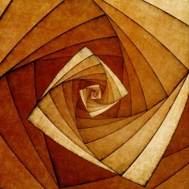

These games and activities are designed to help you support your child with their learning of the times tables.

Specific year groups study different times tables throughout the year, however these activities work with them all!

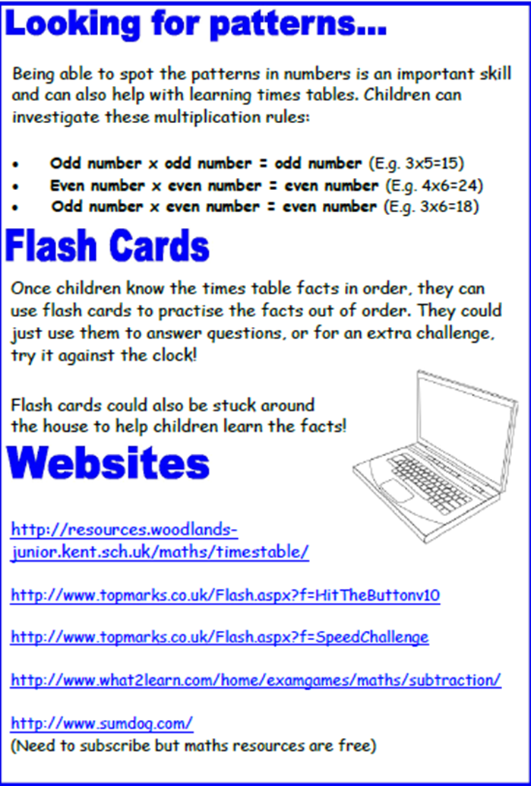
The aim of this booklet is to show you some strategies we use in school and that you could try at home to help children with their tables.
Times table square
Using a times table square is a good way to help visualise all the answers and see the different patterns that occur. In the example below, all the square number answers have been coloured in.
You could create a new times table square for each table and see what patterns are created!
You could look for patterns, such as how the digits change in the 9 times table.

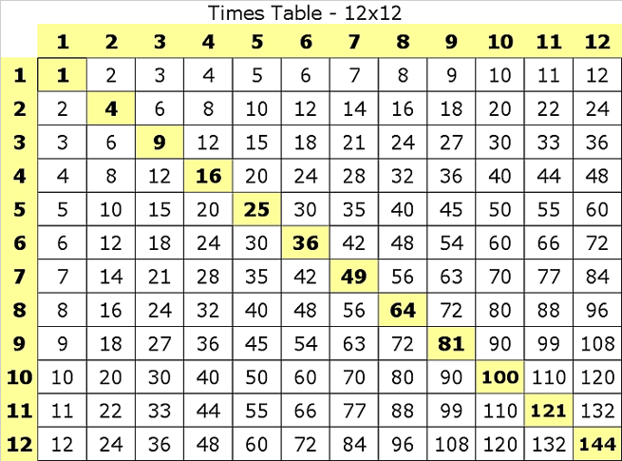

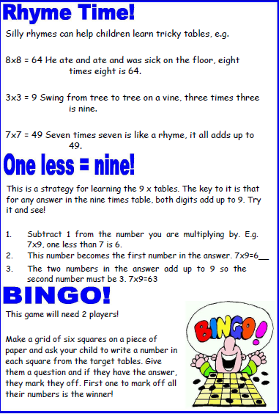
Counting Stick!

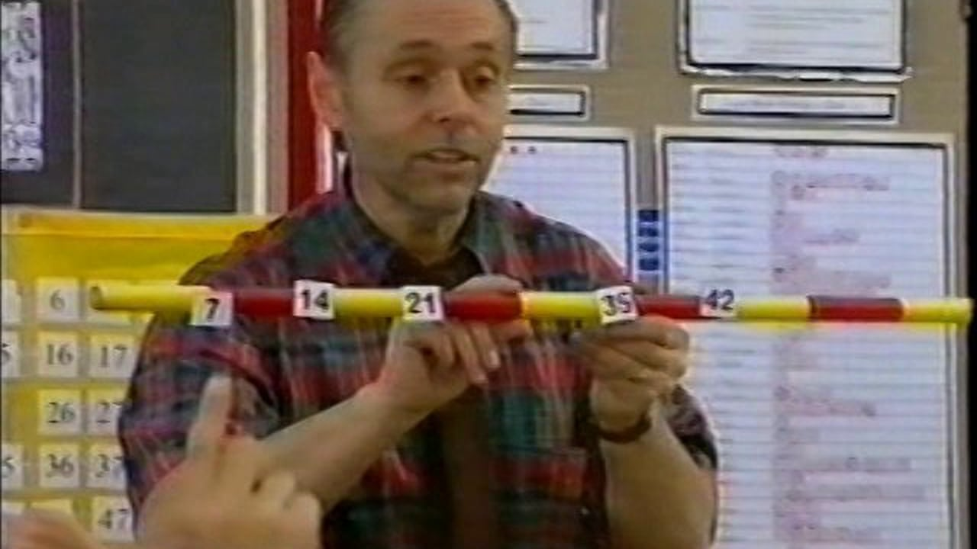
A really useful method for learning all the times tables is with a counting stick.
Each of the answers is placed on the stick and a discussion is held about how to use this fact to find another answer in the times table. This then shows children that they can work out the answers even if they can’t remember them.
This strategy is used in our school and can be viewed on Youtube at:
https://www.youtube.com/watch?v=B8lO_wl2Iys&t=26s
Or,

